Tutorial 01

**What is a mashup?**

Mashup is a web application that combines data from more than one source into a single integrated tool.

**Creating mashup**

Many mashups can be created by simply providing data to Web-based services. As an example, the UK Web Focus list of events is available as an RSS feed as well as a plain HTML page. The RSS feed includes simple location data of the form. This RSS feed can be fed to mashup services, such as the Acme.com service, to provide a location map of the talks given by UK Web Focus, as illustrated.

**Tools for developer**

Tools are being developed which allow mashups to be created by people who may not be developers – the best known is Yahoo Pipes which “provides a graphical user interface for building data mashups that aggregate web feeds, web pages, and other services, creating Web-based apps from various sources, and publishing those apps”.

**Functionality of Yahoo Pipes**

Yahoo Pipes takes RSS feeds from different websites and merges them together into a single RSS feed. Yahoo Pipes can also take raw data or information from websites and covert the contents into RSS feeds. This function is assisted with the use of YQL ‘The Yahoo! Query Language’ which is an expressive SQL-Like language that lets you query, filter, and join data across Web services.

**Uses of Yahoo pipes**

* *Adding information*

RSS feeds usually leave out important fields in the feed to encourage you to click through to the actual website. For example when searching RSS feeds for reviews of PC games, the score of the game is always left out. This forces the reader to click through to the site. Using yahoo pipes you can extract the missing data from the website and add it to the RSS feed. This means for a full review of a PC game you don’t even have to visit a website beyond your dashboard.

* *Filtering*

Yahoo Pipes have a filter module. This allows you to filter content out from RSS feeds that do not interest you. Using my game example again – If I want to filter out Xbox reviews from an RSS feed this can easily be done through Yahoo Pipes.

* *Language conversion*

If there is a news feed or website where your primary language isn’t supported then uses Yahoo Pipes to convert to a language of your choice.

* *Link into social media*

A popular use of yahoo pipes is to link into Flickr and Facebook profiles for feed updates. Yahoo Pipes can also search through social media sites for images or posts linked to a keyword.

**Structure of Yahoo pipes**

The figure shows the overview of the Yahoo Pipe editor. To create or edit a pipe, user has to sign up with a Yahoo! ID. Creation and editing of the pipes are completely online; the user doesn't have to download a plug-in or a program. User selects the "Create a pipe" option to open the Pipe Editor.

Pipe editor is composed of three panes which are the canvas, the library and the debugger. The pipe is created using these panes. After creation, pipe is saved and run. Then user gives a name to the pipe and writes a short description of it. If the creator of the pipe decides to publish the pipe, it becomes visible for everyone. Other users can clone the pipe. Then they can use and edit their copy for their own use.

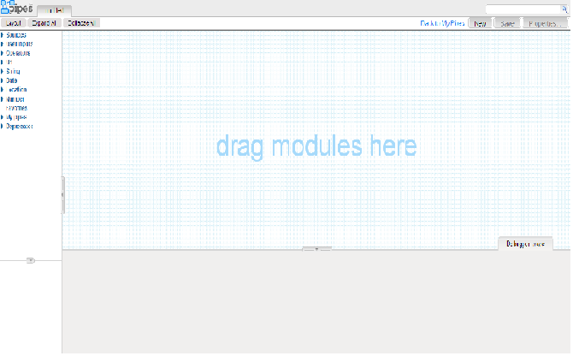

The yahoo pipe editor contains 3 major areas.

* The Canvas

Canvas is the main pane where the editing of pipes is done. It is in the center of the page. Modules that are selected from the Library pane are dragged on this pane and connected together. After that all the modules are wired in the desired order the pipe is ready to be used.

### The Library

The Library is the place where the modules are selected to be dragged on the Canvas. These modules are grouped by their functions. The library pane is on the left hand side.

#### Sources

In this category, there are modules which are used to grab data from one or multiple sources on Internet.

**Example of using Yahoo Pipes**

Let’s do a simple yahoo pipe in yahoo pipe editor.

* Drag the fetch feed from the sources and drop into the canvas.

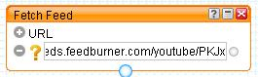

* When the operator is highlighted in orange, the debugger down the bottom of the interface will display the results of the operator.
* You should a list of titles from the RSS feed.

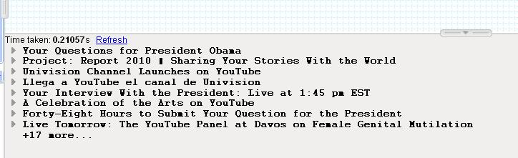

* Repeat step two with a different RSS feed. You now have two RSS feeds with different sources.
* Under ‘Operators’ section, select the union module.
* Connect the bottom of the fetch feeds modules to the top of the union module.
* Connect the bottom of the union module to the Pipe output module.
* Highlight the Pipe output module to make it orange
* Click ‘refresh’ in the debugger down the bottom of the page. It will look like this.



* Save and run the pipe
* You should see a list of news items from both RSS feeds. To use your new feed click on the ‘get as RSS’ icon.



* Under ‘operators’ select the filter module.
* Break the link between the union module and the pipe output module. This is done by clicking near one of the modules. Some scissors will appear which can be clicked on.

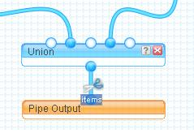

* Connect the bottom of the union module to the top of the filter module. Connect the bottom of the filter module to the top of the pipe output module.
* The filter module can block or permit items that match ‘all’ or ‘any’ of your rules. The English is not clear and this element of the module always ends up as a trial and error process.